CSULB – College of Engineering

Computer Engineering

Senior Design Project

CECS-490A

Dr. Pill

Team:

- Jonathan Cerniaz

- Jehmel Espiritu

- Jeremy Espiritu

- Joseph Guzman

- Afzal Hakim

- Lee Roger Ordinario

Prof - Dan Cregg

## Weekly Report 1

**Last weeks list…**

* N/A

**Did you accomplish what you planned?**

Ever since we decided on the automatic pill dispenser we have been making steady progress towards our design. Everybody has addressed their concerns as well as any confusion that may have come up during our discussions. As for the things we did accomplished we discussed about the following:

* Dispensing design: how the medication would be stored and dispensed; we sketched a design for a drop-down system consisting of a servo motor-powered pivot mechanism ensuring one pill will drop with tubing leading into a tray.
* Storage design: the inventory system of the device; taking into consideration that the machine would need to be refilled at some point, we wanted to provide ease of access to the inner compartments of the device. We plan to make multiple funnel shaped storage compartments with individual lids that are placed to make the shape of a circle, and attaches to separate dispense motors so they are easily detachable so you can replace it with other medication. We also wanted to make it so there are a variety of storage sizes depending on the size of the pill.
* Interface design: the user’s experience when using the device; brainstormed what is of importance for the user to visually see when interacting with the device such as time and date. We wanted the authorized user to have access to the machines dispense history as well as storage level.
* Software design: the top-down design of our device; the two groups that would use the device, staff (authorized personnel) and user(s). Considering the security measures that would need to be implemented, such as allowing the staff to access the storage and medication log of the device. Whereas user(s) are only allowed to obtain medication dependent on the identification of the said user.

**If not, why?**

Due to a lack of time we were unable to figure out:

* + The prevention of stuck pills (clogging).
  + Prevention of crushed or damaged pills.
  + Layout of storage compartments.
  + The materials that are cost efficient yet strong enough to hold the containers and desired interfaces.
  + How many different types pills will be in each machine.
  + How big the storage compartments would be.
  + Object recognition placement and implementation.

**Are all team members accounted for?**

Yes, we are all accounted for, and we are communicating consistently. In addition to the in-person discussions (which happen Mon-Fri) in other classes, we plan to meet virtually every Friday to further discuss any questions, concerns or plans.

**Next week plan, specific to each individual:**

Jonathan Cerniaz:

* List of potential material for pill storage and enclosure.
* Placement of object recognition.
* Information on safety with certain medicines to prevent cross contamination, crushed pills, sanitary environment.

Jehmel Espiritu:

* Logistics of the pill dispensing mechanics.
* Research on motors for our design.

Jeremy Espiritu:

* Logistics of the pill dispensing mechanics.
* Figure out the daily medication intake for the average older adults and elderly.

Joseph Guzman:

* 3D print of group-approved prototype design.
* Schematics and drawings.

Afzal Hakim:

* Research on App creation for Alarm and Reminders.
* Research on Data Storage for Log Tracking.

Lee Roger Ordinario:

* Improve on the design developed (such as where wires need to be/could be hidden, storage refilling, etc.)

**Drawings/Sketches**

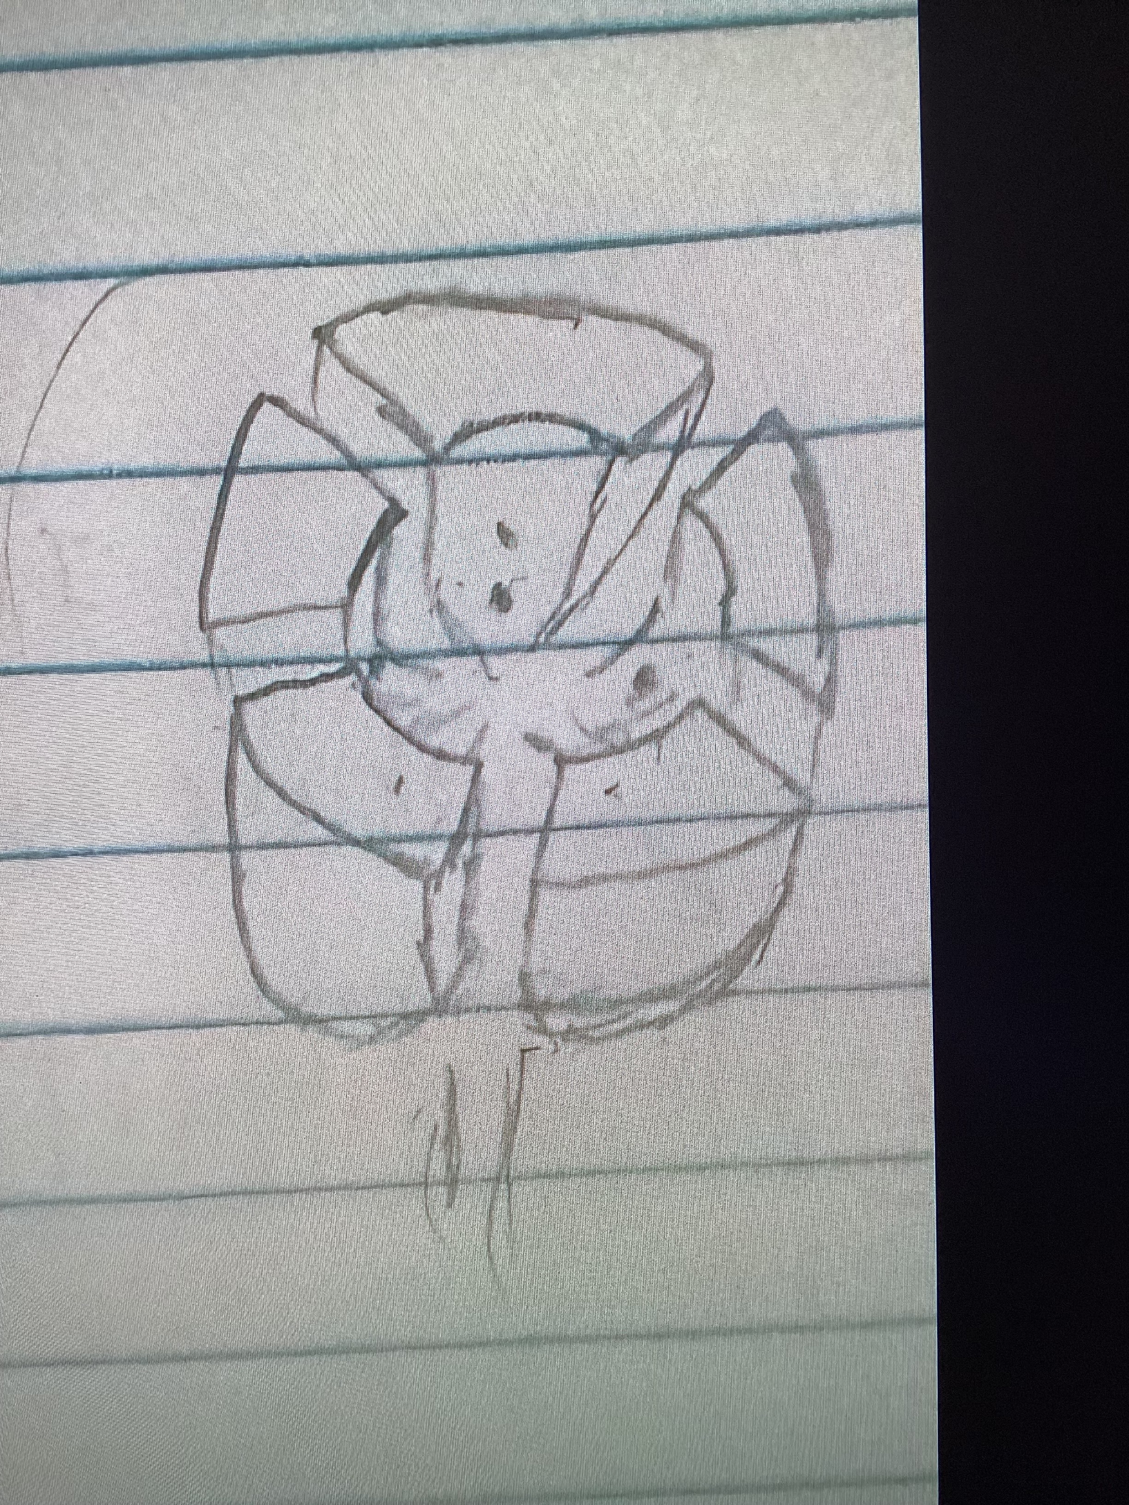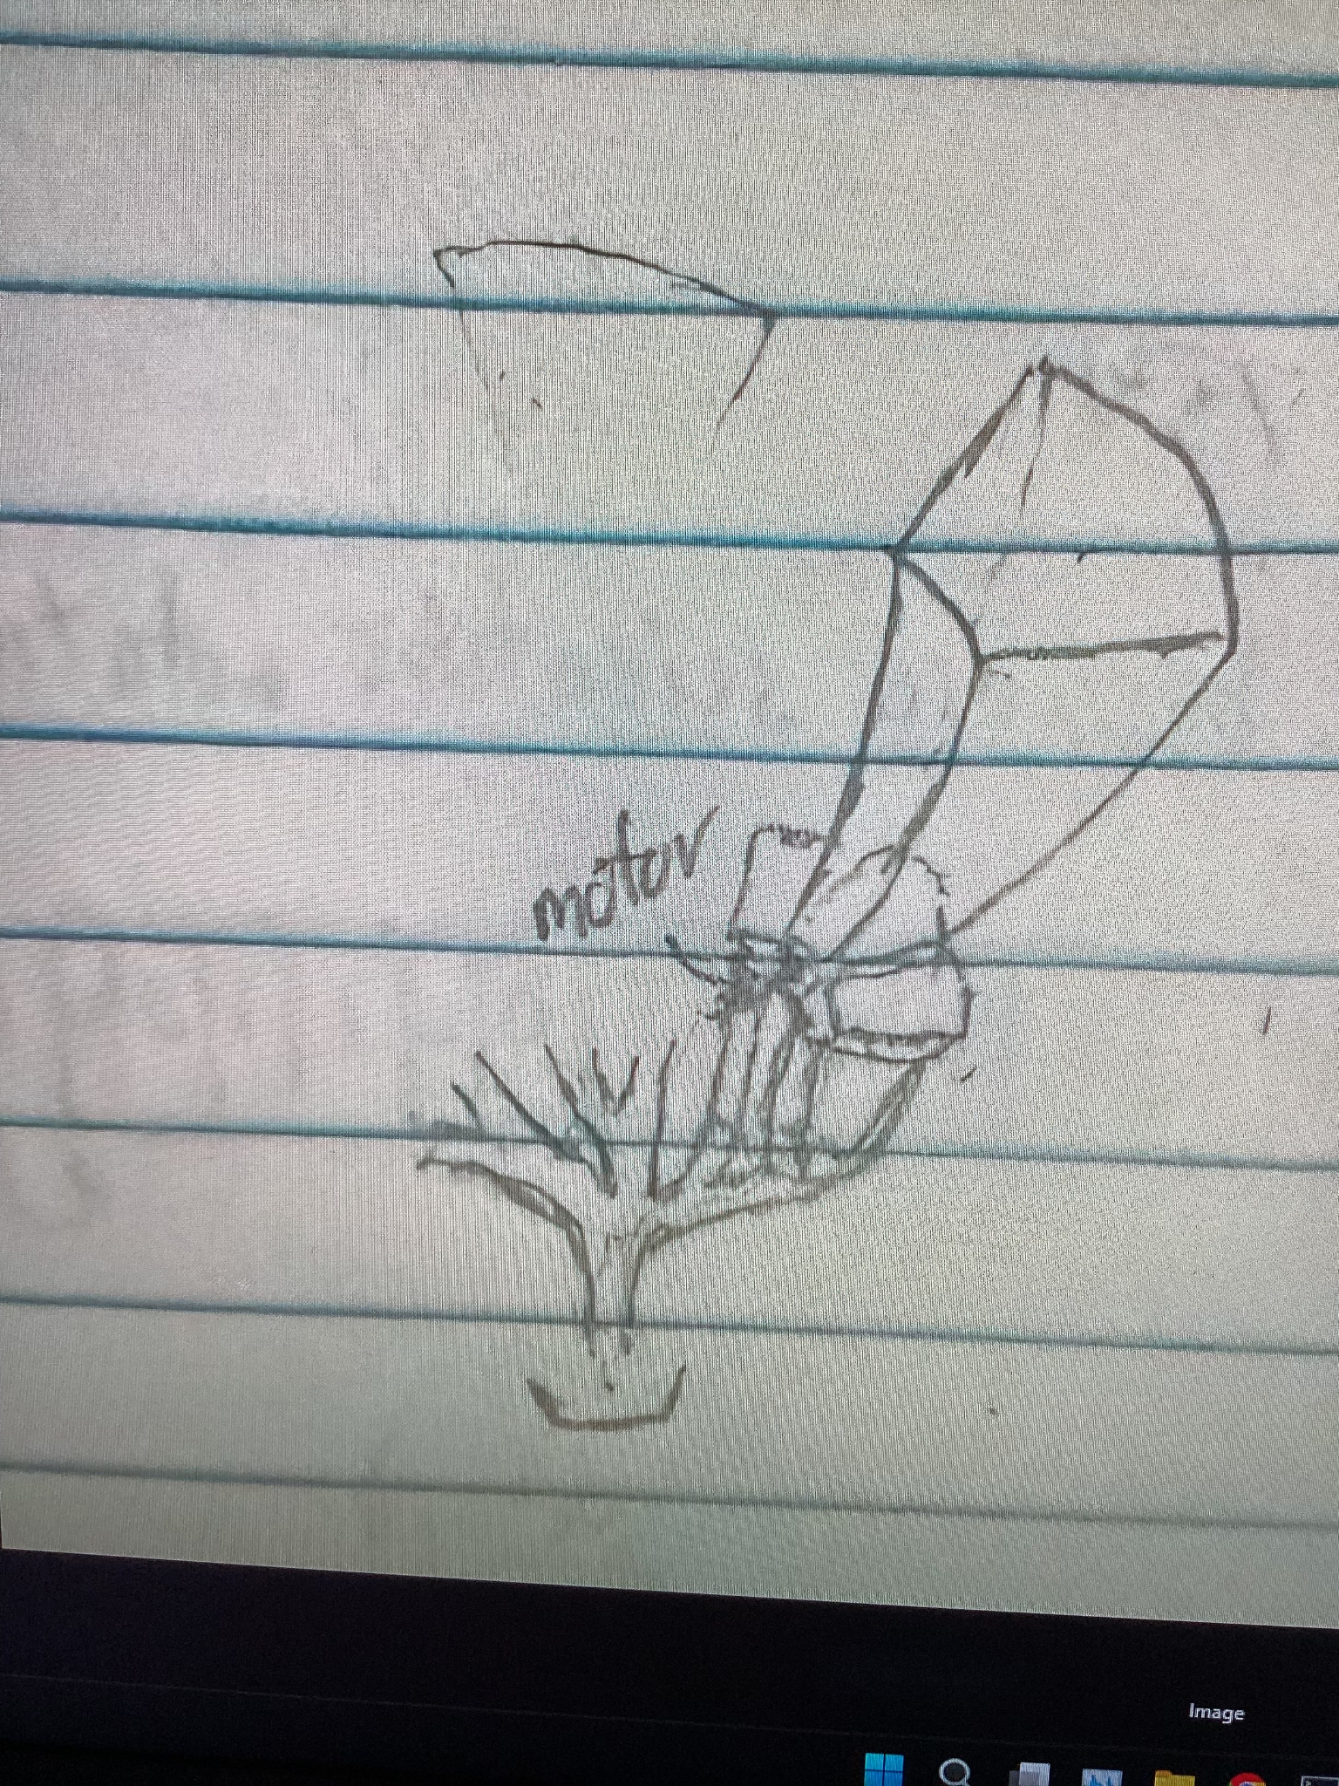

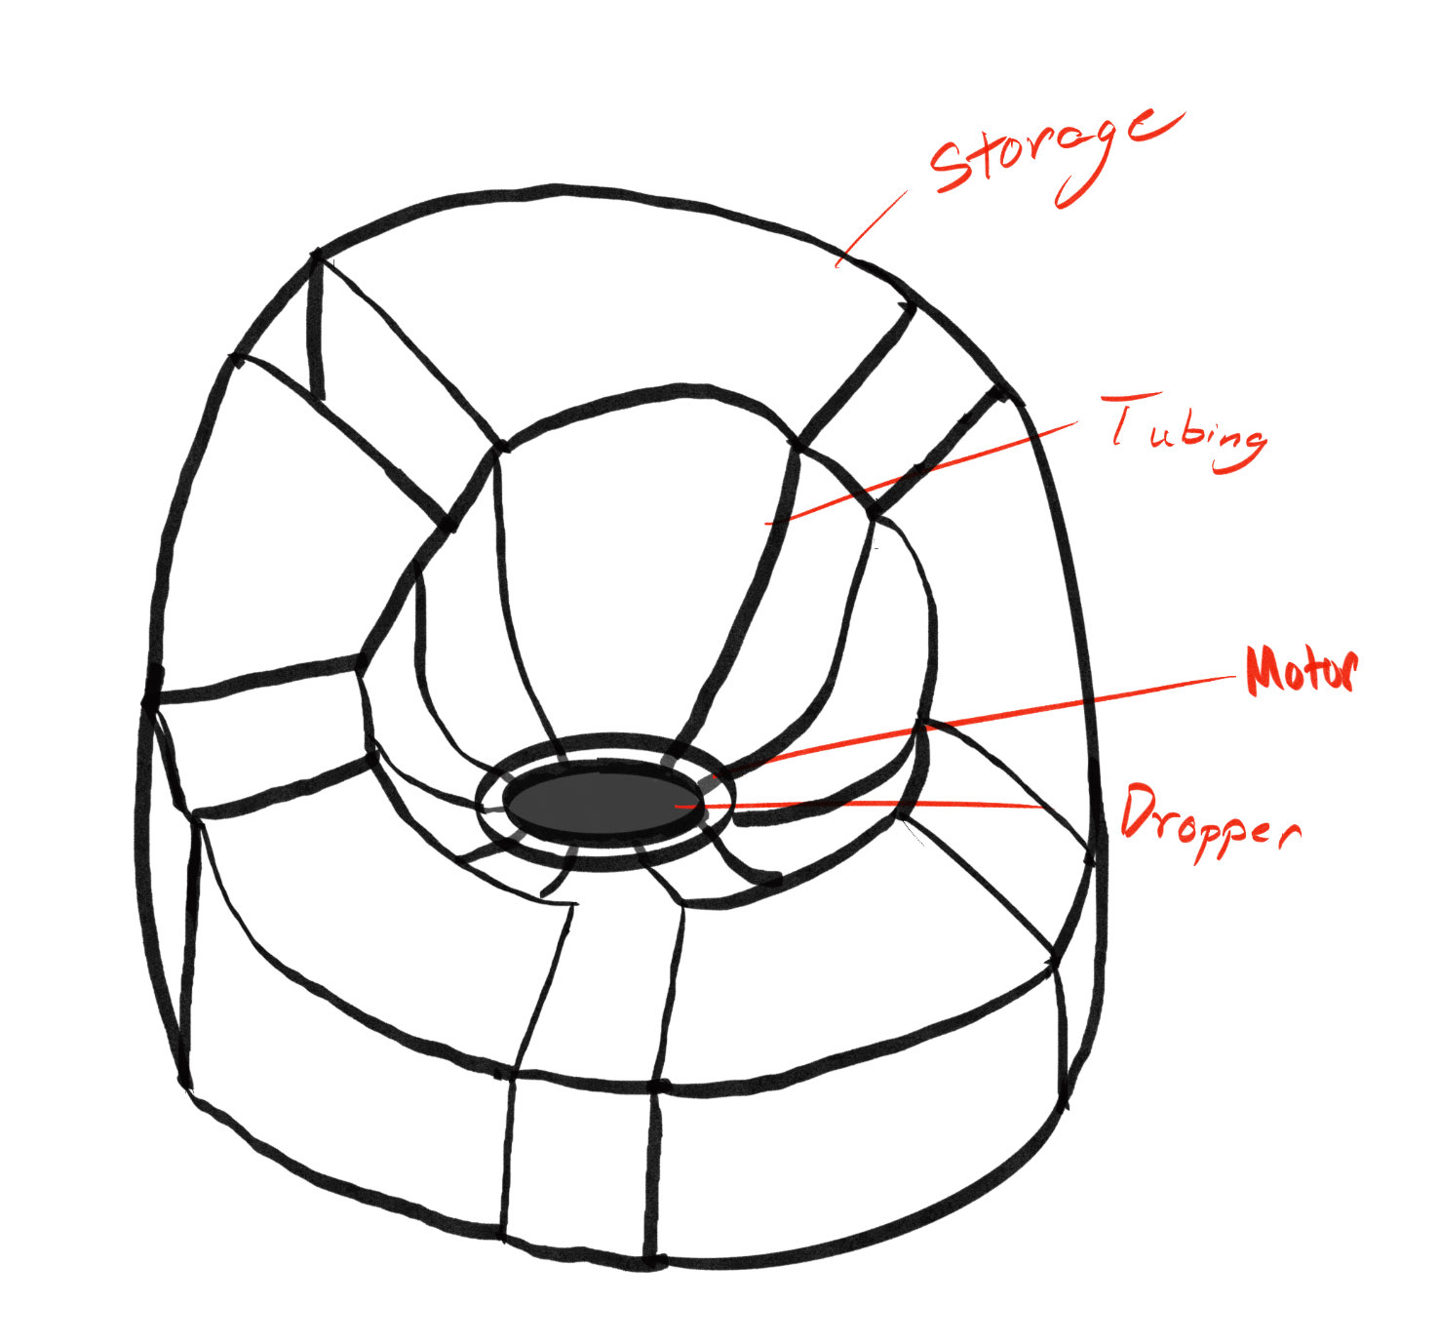

**09/16/24 Meeting**

| Dispensing design |  |
| --- | --- |
| Interface design |  |
| Storage design |  |
| Software design |  |

**3D Print Samples**

